From India to the Caribbean:

The Traditional LILA Style of Ram Lila
By Pandita Dr. Indrani Rampersad
(former Research Fellow in Ram Lila/Ramdilla Studies at University of Trinidad and Tobago)

Introduction

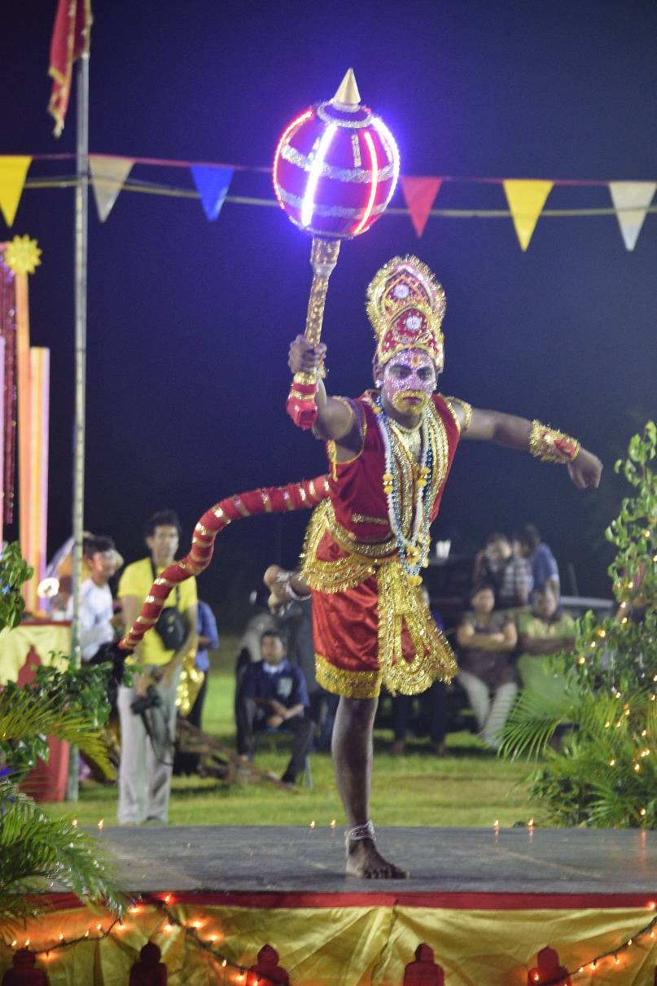
Ram Lila and Krishna Lila are two folk performances, among several others, that the indentured Indians brought with them from India to the Caribbean between 1838 and 1917. The North Indian cultural traditions were dominant.
The term “Ram Lila” is now loosely used, both in India and the Caribbean, to refer to both the open-air style and the proscenium stage style of telling the story of Ram.
I see a major difference between the two styles, deeming the open-air style as the LILA style, using lokadharma open-air theatre conventions, folk, amateur, and bhakti-oriented, and with the text being the center of the performance. The text directs the performance; the vyas delivers the text in katha tradition; and the audience listens, as an act of devotion, to the recitation.
The proscenium stage style uses Natya conventions, stylized movements, dramatic/theatrical, performed by amateurs in Trinidad, more focused on setting, costuming, make-up, dialogue, etc. Today, in several performances in Trinidad (both LILA and Natya) the vyas is replaced by a narrator or two using English dialogue, with little or no recitation from the Ramcharitmanas. The katha style of story-telling is central to the LILA style. Katha is one of the ingredients of Bhakti, the others being kirtan, dance, bhajan, and lila. In Ram Lila, the vyas is the narrator who is skilled in this katha style, and as he recites from the text, he interprets and makes connections with self, other texts, the world, and the audience.
Hanuman with stunning make-up and battery-lit mukdar, lights up the end of the day’s Lila as he prepares to fly over the ocean to Lanka. Baal Ramdila open-air performance, 2015. Photo by Pandita Indrani
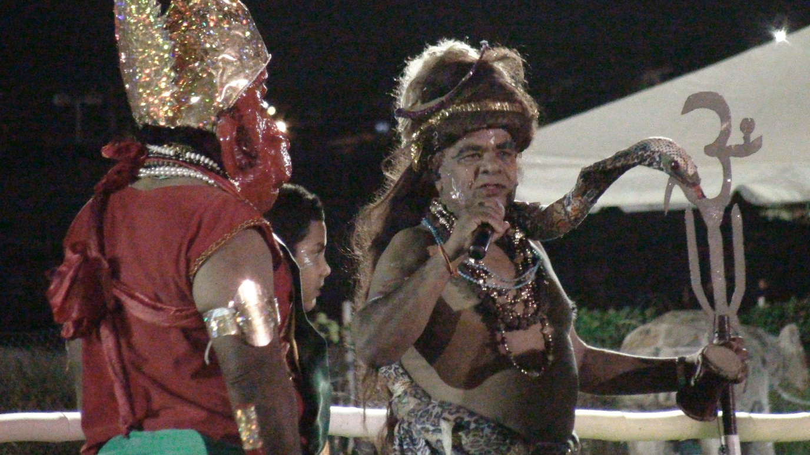
Sadhu-Ji narrates, by rote, from the Ramcharitmanas in his role as Shiva telling the katha. In this role of vyas/narrator, he directs the Lila. (Tarouba Ram Lila, 2014, Photo by Pandita Indrani)
Obviously, the attitude with which all LILA stakeholders engage, for example, would include bhakti (unconditional love and surrender to the avatar; kirtan, dance, and bhajan), volunteerism, sankalpa (taking a vow to complete a religious act), yajna (for the greater good of community), and seeking darshan (spiritually transformative experience of receiving the prasad/grace of Sri Ram through “seeing” and “being seen” by Him in the living image of the swaroopa).
In Trinidad and Suriname, Ram Lila is characterized by the LILA style that still exists in some villages in North India (like Pura Bazaar (Faizabad), Sahabganj (Ayodhya), Akbarpur (Kanpur Dehat), Baxi-ka -Talab (Rudhi Village, Lucknow), Bhaidani (Benares), Jaswantna-gar (Etawah), and Ramnagar (Benares). I. Some of the open-air Trinidad Ram Lila-s, performing in LILA style include: Baal Ramdilla (Hindu Prachar Kendra, Longdenville; Bluebirds Sports and Cultural Organisation (Barrackpore); Brickfield Shiva Mandir (Carapichaima); Cedar Hill Youth Social and Cultural Organisation (Tarouba); Dow Village Ramleela and Cultural Organisation Inc. (California); First Felicity Ramleela and Cultural Group (Felicity); Knox Streett and Environs Sports and Cultural Association (San Fernando); Mc Bean Ramleela and Cultural Group (Couva); Param Dhaam Ram Lila, Penal; Pierre Road Ramleela Committee (Charlieville); Rio Claro Ram Leela Committee (Rio Claro); Sangre Grande Ramleela Committee (Sangre Grande); St John's Trace (Avocat); Sri Raam Indian Cultural Association (Princes Town); and Tarouba Ram Leela Committee (Marabella).
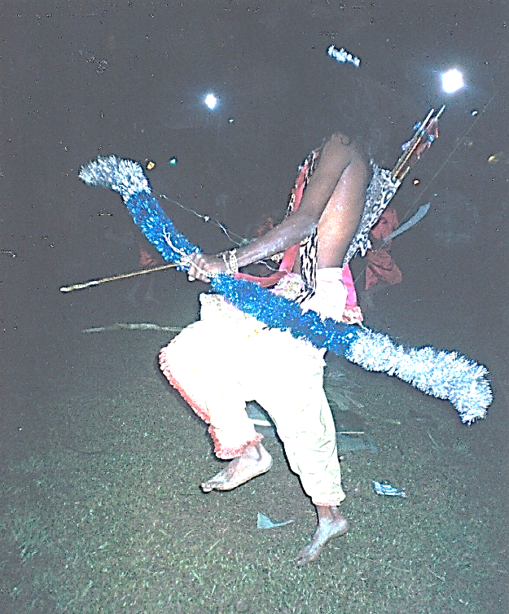
There are many proscenium stage Natya style Ram Lila performances in towns and cities of North India, today. There, the performers are likely to be professional or semi-professional travelling troupes from outside of the community. In India, this style has taken prominence over the older village open-air, LILA style that really unifies a community through the audience, performers, organizers, artisans, and supporting staff, all coming from within the community. In Trinidad, Guyana and Suriname, this style is adopted mainly by some mandir groups.

Miming in the LILA Style
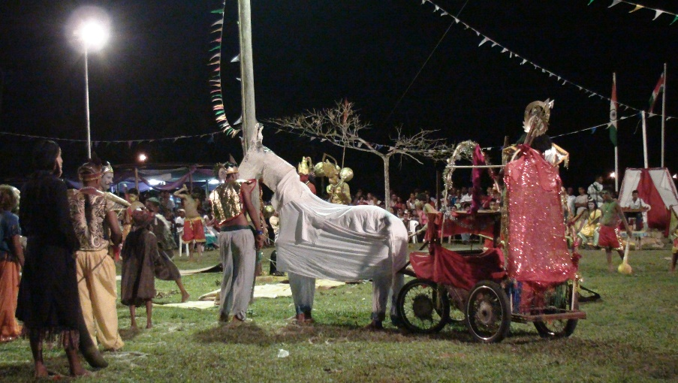
In the LILA style, the performance takes place in the open-air, with the sky as the roof and the earth as the floor. The performers, audiences and all are part of the greater cos-mic setting with the various loka-s, devi-s and devata-s easily accessible – it is a cosmic experience. Miming is an integral aspect of the LILA art-form, where performers enact the narrative as told the vyas, reciting in traditional style from the Ramchartimanas. The art of miming the deeds of Lord Vishnu is called “imitation Lila” and it is the devotee’s humble way of remembering the deeds of the Lord and strengthening faith in Him. Lord Vishnu is said to be the originator of the art of mime, and mimetic dramas drew upon His sacred narratives (like Ram and Krishna Lila).
Sri Ram mimes the aerial step of divine characters at Tarouba Ram Lila. This style came with the indentured Indians (photo by Ravi-Ji, 1985).
Left: Pantomime Horse in Suriname, 2008. Here two men synchronize their movements to move the chariot. One performer is at the front and another at the back with an artificial horse head at the front. The performer at the back has to bend and hold the waist of the one at the front and move in synchrony (photo by Pandita Indrani, 2008).

Vaishnava Worldview
Ram Lila rose in popularity in North India during the sixteenth century when enactments of the Ramcharitmanas captured the devotional mood of the masses through language and performance. This culture came to define the identity of the people and communities across the North Indian belt, where the Ramcharitmanas reigned.
When, in 2005, UNESCO proclaimed Ram Lila one of the Masterpieces of the Oral and Intangible Heritage of Humanity, it recognized the value of Lila to community life. Communities are not artefacts of tourism but living, dynamic organisms, with living traditions that express their cosmic realities. Ram Lila and Krishna Lila are examples of devotees manifesting the Vaishnava worldview through Lila and incorporating other elements of bhakti, like kirtan, dance, bhajan, and katha. This form of bhakti expression had great appeal to the North Indian masses and to the indentured Indians and their descendants that inherited this culture.
There is definitely a feeling amongst some Trinidad Ram Lila stakeholders today (more of the elite, educated class) that the open-air Ram Lila style is too unsophisticated as a tourism (domestic or foreign) attraction, and also for contemporary audiences, especially the youths who have many alternative forms of recreation. However, Ram Lila is a community event and ought not to change its format to suit the eye of the tourist. If tourists come, they should come to see that which is indigenous to the community and not contrived for entertainment needs. While Ram Lila provides entertainment and education, it is essentially saatwik and devotional at the core.
Need to improve Lila presentations
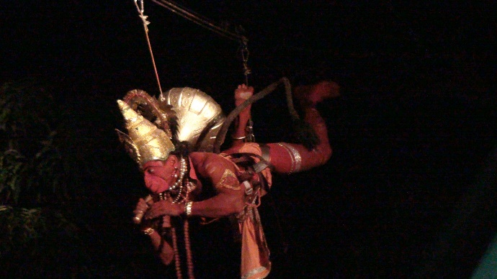
There is validity in the argument that the open-air performances need to improve their overall presentation to meet the new needs of an increasingly urbane community. Change is an ongoing process as groups, with time and funding, improve their costuming, props, mimetic movements, dance movements, processions and circumambulations, etc. The Baal Ramdilla of The Hindu Prachar Kendra is the only one in the country that undergoes annual formal training for periods of six to eight weeks, with children and youths learning all aspects of organizing and performing Ramdilla. This training is followed by their actual performance in the Ram Lila season.
A major concern, however, is over the demise of Indian aesthetics and the privileging of Western aesthetics in Ram Lila. There is a weak or no appreciation of Indian aesthetics and the conventions of natyadharma in Trinidad society.
Right: Flying Hanuman at Vreedenburg Ram Lila, Suriname (2008). Photo by Pandita Indrani
New stage performances of Ram Lila in Trinidad use western aesthetics under the directorship of local dramatists whose training is in that style, exclusively.
To ensure the continuity of Ram Lila, community members must take ownership as the ancestors did. External professionals or performers will not ensure that continuity. The ritualism associated with Ram Lila is also central to its ethos and continuity – this is diluted or removed from stage performances.
Some have replaced the recitation of original verses of Ramcharitmanas with dramatic dialogue in English. The religious act of listening (sravanam) as a form of devotion, is lost in such performances. The movements do not conform to Indian aesthetics. The informal, mela-like atmosphere of the community Lila is lost, creating greater social distance between stakeholders. Miming has been replaced by western style dramatization, losing the Indian aesthetic in the process.
There is the obvious and urgent need for training in natyadharma conventions for telling the story of Ram on the Trinidad stage and in adherence to Indian aesthetics.
It is instructive that Ram Lila in North India, today, is facing a serious threat from the competing Navratri Devi Puja-s that take place at the same time and nearby spaces, and that allow for more interaction between audiences and objects of worship and reverence. Could the replacement of the LILA style of telling the Rama story with the proscenium stage style, have been a factor in this change? When the open-air Ram Lila in Suriname went to the stage, it saw a decline in the number of Lila-s being performed and today there are only two open-air performances.
In Trinidad, there are some twenty-four (24) open-air Ram Lila performances in the country, several proscenium stage style performances in mandir space, mainly, and over fifty (50) on school stages across the country. In Guyana, Gopaal Mandir at Lusignan resurrected the open-air Ram Lila with performances in 2008, 2009, and 2015. In Suriname, there are two open-air Ram Lila performances – at Vreedenburg and Leiden No 9.

